**LAB MANUAL**

**Day – 1 | ARTIFICIAL INTELLEGENCE**

**Self-Practice**



**To create the Mask identification using lobe.ai**

**To create the Mask identification using lobe.ai**

**Objective:**

Creating a Mask Identification ML model using Lobe.ai involves similar steps to creating other image classification models. To Ensure each image is labeled accordingly (e.g., "with_mask" and "without_mask").

**Equipment Required:**

1. Computer with internet access
2. Lobe.ai tool installed

**Problem Statement:**

To create the Mask identification using lobe.ai

Step 1 : you can import your image dataset only with folders so you can’t use CSV files. But Lobe does allow you label your images if they are not in labeled or categorized in folders yet.

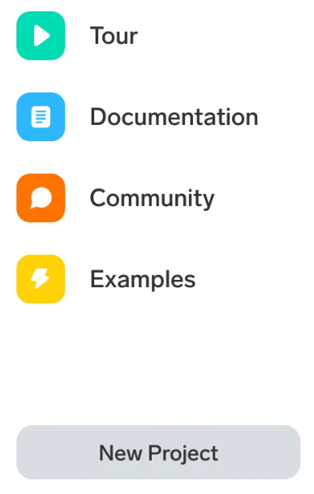

Step 2: <https://www.kaggle.com/datasets/dhruvmak/face-mask-detection> Download your Data.

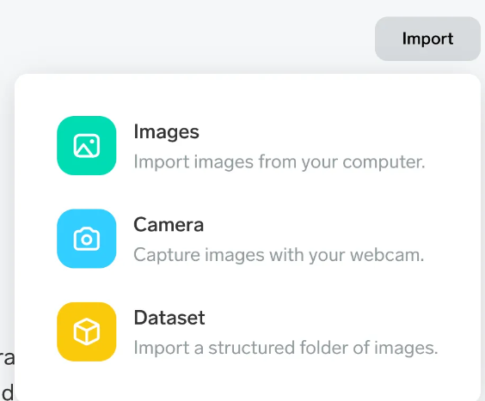

After importing your dataset, Lobe starts training immediately.

Step 3: Lobe automatically splits 20% of your to dataset to test your model. Test images are a random subset of your examples are not used during training.

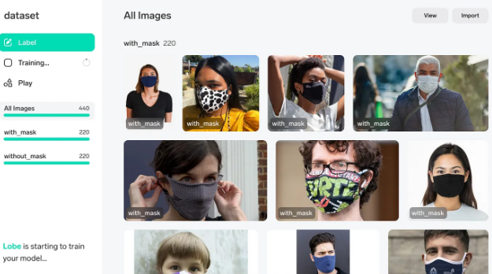

Step 4: In the left panel you can see your dataset details. You can click on these folder names to check your images.

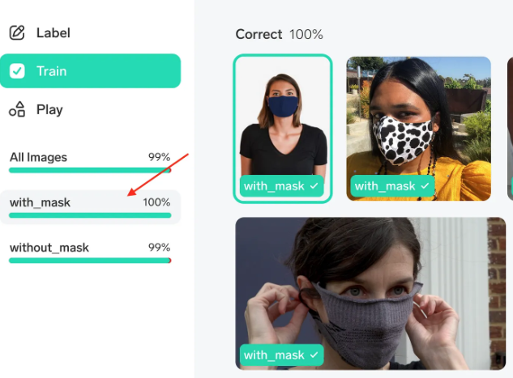

Lobe shows the training process live in the lower area in the left panel. There you can see how many images it predicts correctly or incorrectly. 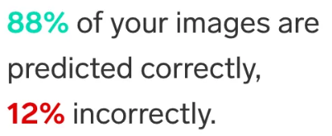

Step 5: You can leave the app while training, as it notifies you with a click sound when training finishes. For this dataset -which has 440 images- training finished under five minutes. When training finishes, you can check the results and see the correct/incorrect classifications that your model made.

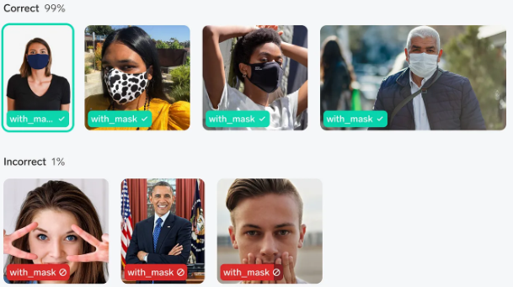

Hovering over the image will show you the confidence score of the model.

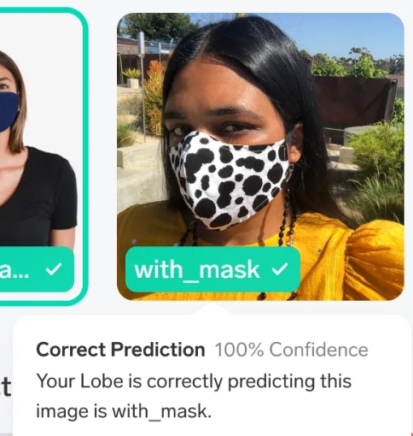

Step 6: To see the accuracy of your model on test images, you can select View > Test Images. It will show your model’s accuracy on test images it hasn’t seen before.

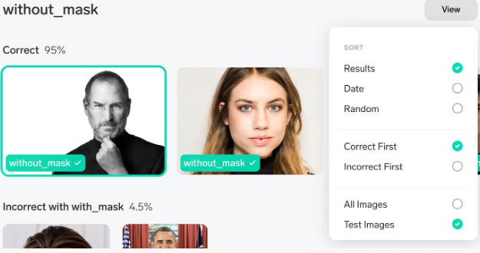

Step 7: In the Play section, you can drag-drop new images or take photos with your webcam. Lobe will run the trained model with this new image and you can see how good your model does with the new images.

